**WEEK-2**

**MODULE -3**

**PL/SQL PROGRAMMING**

**SUPERSET ID:6407550**

**Exercise:2-Error Handling**

-- Create two accounts

INSERT INTO Accounts (AccountID, CustomerID, AccountType, Balance, LastModified)

VALUES (3, 1, 'Savings', 50, SYSDATE); -- Low balance account

INSERT INTO Accounts (AccountID, CustomerID, AccountType, Balance, LastModified)

VALUES (4, 2, 'Checking', 1000, SYSDATE);

INSERT INTO Customers (CustomerID, Name, DOB, Balance, LastModified)

VALUES (7, 'Duplicate Don', TO_DATE('1991-01-01', 'YYYY-MM-DD'), 5000, SYSDATE);

**Scenario:1**

CREATE OR REPLACE PROCEDURE SafeTransferFunds(

p_FromAccountID IN NUMBER,

p_ToAccountID IN NUMBER,

p_Amount IN NUMBER

) IS

v_FromBalance NUMBER;

BEGIN

SELECT Balance INTO v_FromBalance FROM Accounts WHERE AccountID = p_FromAccountID;

IF v_FromBalance < p_Amount THEN

RAISE_APPLICATION_ERROR(-20001, 'Insufficient funds in the source account.');

END IF;

UPDATE Accounts SET Balance = Balance - p_Amount WHERE AccountID = p_FromAccountID;

UPDATE Accounts SET Balance = Balance + p_Amount WHERE AccountID = p_ToAccountID;

COMMIT;

DBMS_OUTPUT.PUT_LINE('✅ Transfer successful.');

EXCEPTION

WHEN OTHERS THEN

ROLLBACK;

DBMS_OUTPUT.PUT_LINE('❌ Transfer failed: ' || SQLERRM);

END;

/

**OUTPUT:**

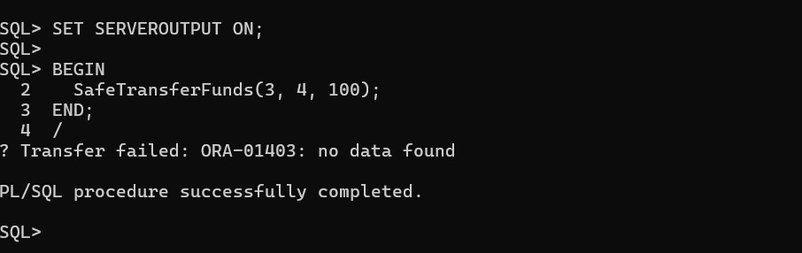

**Scenario:2**

CREATE OR REPLACE PROCEDURE UpdateSalary(

p_EmployeeID IN NUMBER,

p_Percent IN NUMBER

) IS

v_OldSalary NUMBER;

BEGIN

SELECT Salary INTO v_OldSalary FROM Employees WHERE EmployeeID = p_EmployeeID;

UPDATE Employees

SET Salary = Salary + (Salary * p_Percent / 100)

WHERE EmployeeID = p_EmployeeID;

COMMIT;

DBMS_OUTPUT.PUT_LINE('✅ Salary updated for Employee ID ' || p_EmployeeID);

EXCEPTION

WHEN NO_DATA_FOUND THEN

DBMS_OUTPUT.PUT_LINE('❌ Error: Employee ID ' || p_EmployeeID || ' not found.');

WHEN OTHERS THEN

DBMS_OUTPUT.PUT_LINE('❌ Unexpected error: ' || SQLERRM);

END;

/

**OUTPUT:**

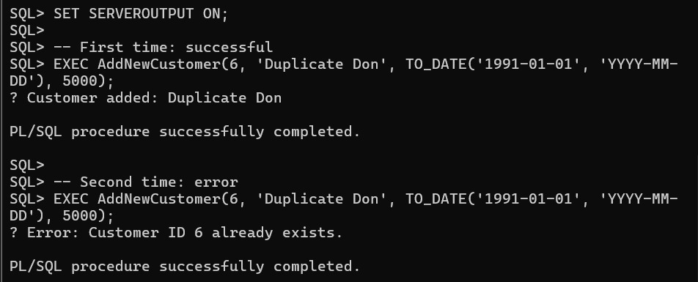

**Scenario:3**

CREATE OR REPLACE PROCEDURE AddNewCustomer(

p_CustomerID IN NUMBER,

p_Name IN VARCHAR2,

p_DOB IN DATE,

p_Balance IN NUMBER

) IS

BEGIN

INSERT INTO Customers (CustomerID, Name, DOB, Balance, LastModified)

VALUES (p_CustomerID, p_Name, p_DOB, p_Balance, SYSDATE);

COMMIT;

DBMS_OUTPUT.PUT_LINE('✅ Customer added: ' || p_Name);

EXCEPTION

WHEN DUP_VAL_ON_INDEX THEN

DBMS_OUTPUT.PUT_LINE('❌ Error: Customer ID ' || p_CustomerID || ' already exists.');

WHEN OTHERS THEN

DBMS_OUTPUT.PUT_LINE('❌ Unexpected error: ' || SQLERRM);

END;

/

**OUTPUT:**

